Белорусский государственный технологический университет
Факультет информационных технологий
Кафедра программной инженерии

Лабораторная работа 7
По дисциплине «Основы Алгоритмизации и Программирования»
На тему «Полустатические структуры данных: стеки»

Выполнил:
Студент 1 курса 6 группы
Качинскас Вацловас Вацловович
Преподаватель: асс. Андронова М.В.
2023, Минск

main.cpp
#include "stack.h"

const char menu[] = "\t1-input\n\t2-clear\n\t3-output\n\t4-save\n\t5-load\n\t6-func\n\t0-exit\n";

int main()
{
stack* p = nullptr;
char switch_on = 1;
do
{
cout << menu << "input: ";
cin >> switch_on;
switch (switch_on - '0')
{
case 1:cout << "Input: "; input(p, cpInput());
break;
case 2: outputAll(p);
break;
case 3:output(p);
break;
case 4: toFile(p);
break;
case 5: fromFile(p);
break;
case 6: func(p);
break;
case 0: break;
default: cout << '?' << endl;
break;
}
} while (switch_on != '0');
return 0;
}

stack.h
#pragma once
#include <iostream>
using namespace std;
typedef int forStack;
struct stack
{
forStack data;
stack* next;
};
forStack cpInput();
forStack output(stack*& st);
void input(stack*& st, forStack d);
void toFile(stack*& myStk);
void fromFile(stack*& myStk);
void outputAll(stack*& myStk);
void func(stack*& myStk);
stack.cpp
#include "stack.h"
#include <fstream>

forStack cpInput() {
forStack tmp;
cin >> tmp;
return tmp;
}

forStack output(stack*& st) // output element
{
if (st != NULL) {
forStack tmp = st->data;
stack* pv = st;
st = st->next;
delete pv;
cout << tmp << endl;
return tmp;
}
else {
cout << "Empty" << endl;
return NULL;
}
}
void input(stack*& st, forStack d) // Input element
{
stack* pv = new stack;
pv->data = d;
pv->next = st;
st = pv;
}

void toFile(stack*& myStk)
{
stack* e = myStk;
stack buf;
ofstream frm("base.koi");
if (frm.fail())
{
cout << "\n Error";
exit(1);
}
while (e)
{
buf = *e;
frm.write((char*)&buf, sizeof(stack));
e = e->next;
}
frm.close();
cout << "stack in base.koi\n";
}

void fromFile(stack*& myStk)
{
stack buf, * p = nullptr, * e = nullptr;
ifstream frm("base.koi");
if (frm.fail())
{
cout << "\n Error";
exit(1);
}
frm.seekg(0);
frm.read((char*)&buf, sizeof(stack));
while (!frm.eof())
{
input(e, buf.data);
frm.read((char*)&buf, sizeof(stack));
}
frm.close();
while (e != NULL)
{
buf.data = output(e);
input(p, buf.data);
myStk = p;
}
cout << "\nstack out base.koi\n\n";
}

void outputAll(stack*& myStk)
{
stack* e = myStk;
if (e == NULL)
cout << "Empty" << endl;
while (e != NULL)
cout << output(e) << " ";
cout << endl;
}

void func(stack*& myStk) {
forStack tmp[2] = { output(myStk) , output(myStk) };
while (tmp[1] != NULL && tmp[0] != NULL)
{
if (tmp[0] == tmp[1]) {
cout << "true" << endl;
return;
}
tmp[0] = tmp[1];
tmp[1] = output(myStk);
}
cout << "false" << endl;
return;
}
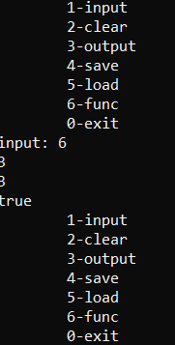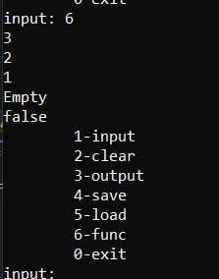
void func(stack*& myStk) {
stack* pos_stack = new stack;//memory for a stack
pos_stack = NULL;//set the pointer to the first element
stack* neg_stack = new stack;
neg_stack = NULL;
forStack buf = output(myStk);

while (buf != NULL) {
if (buf > 0) {
stack* new_even = new stack;
new_even->data = buf;
new_even->next = pos_stack;
pos_stack = new_even;
}
else if (buf < 0) {
stack* new_odd = new stack;
new_odd->data = buf;
new_odd->next = neg_stack;
neg_stack = new_odd;
}
buf = output(myStk);
}

stack* pos_current = pos_stack;
if (pos_current == NULL) {
cout << "Empty" << endl;
}
else {
cout << "Pos stack: ";
while (pos_current != NULL) {
cout << pos_current->data << ' ';
pos_current = pos_current->next;
}
cout << endl;
}
//print
stack* neg_current = neg_stack;
if (neg_current == NULL) {
cout << "Empty" << endl;
}
else {
cout << "Neg stack: ";
while (neg_current != NULL) {
cout << neg_current->data << ' ';
neg_current = neg_current->next;
}
cout << endl;
}

}
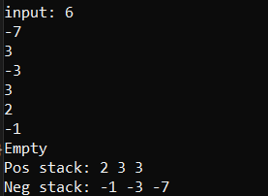
void func(stack*& myStk) {
if (myStk == nullptr) {
cout << "Empty" << endl;
return;
}
stack* outer_prev = myStk;
stack* outer = myStk->next;
while (outer != nullptr) {
if (outer->data < 0) {
stack* temp = outer;
outer_prev->next = outer->next;
delete temp;
stack* print = myStk;
cout << "Stack: ";
while (print != NULL) {
cout << print->data << ' ';
print = print->next;
}
cout << endl;
return;

}
outer_prev = outer;
outer = outer->next;
}
}
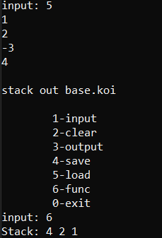
void func(stack*& myStk) {
if (myStk == nullptr) {
cout << "Empty" << endl;
return;
}
stack* outer_prev = myStk;
stack* outer = myStk->next;
while (outer != nullptr) {
if (outer->data > 0) {
stack* temp = outer;
outer_prev->next = outer->next;
delete temp;
stack* print = myStk;
cout << "Stack: ";
while (print != NULL) {
cout << print->data << ' ';
print = print->next;
}
cout << endl;
return;

}
outer_prev = outer;
outer = outer->next;
}
}
